PROBLEM 2

C)

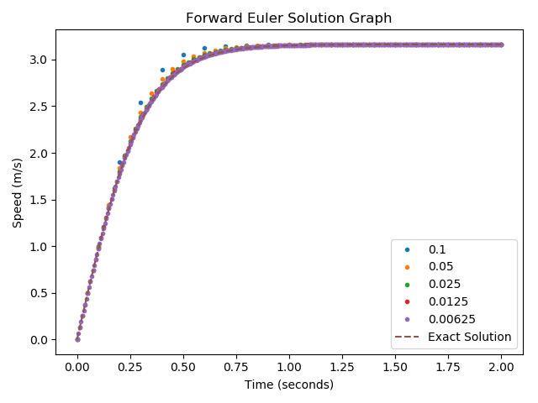

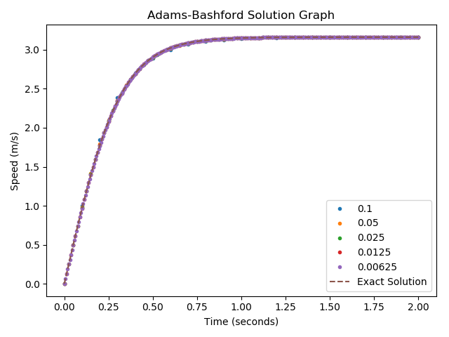

D)

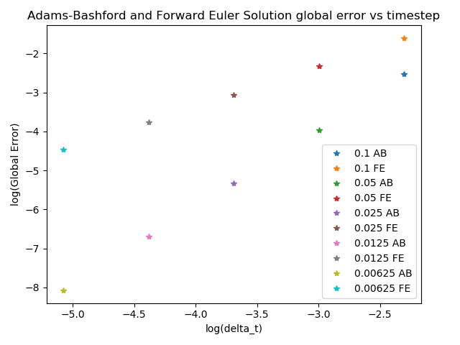

As expected, there is a linear trend in the log-log graph for error and timestep for both methods. Specifically, the observed slope of the line for Forward Euler is one, as expected for a method with first order of accuracy. For the Adams-Bashford method we see that the slope is two, as expected for a method that has the second order of accuracy.

E)

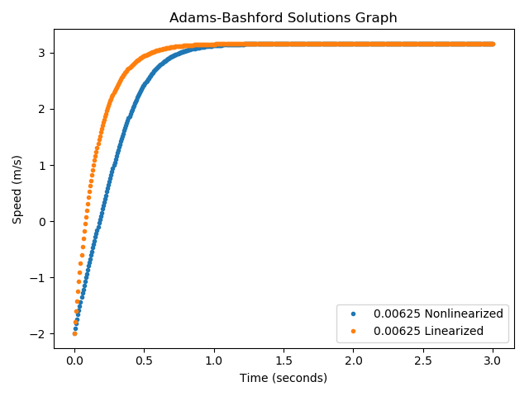

The graph above shows that the linearized version of the ODE results in a quicker convergence to the terminal velocity, as compared to the original (nonlinearized) version of the ODE. The main cause of this behavior is neglecting higher order terms that are due to drag effects. The linearization of the ODE was done for speeds close to the terminal one, but in the beginning of the problem we are far away from the terminal velocity regime, so the difference between solutions is more significant there.